


IoT and Machine Learning Based Smart Hostel Energy Management and Room Occupancy Monitoring System

GROUP-3

BISHAL ROY
KALPAYAN DE
ANANYA BHUSHAN
DEEPSEKHAR PAUL

SUPERVISED BY
Prof. (Dr.) Sheli Sinha Chaudhuri

NETAJI SUBHASH ENGINEERING COLLEGE

Supervisor

Abstract
The increasing demand for electrical energy and the associated problem of energy wastage highlight the need for efficient energy management, particularly in residential and hostel environments where electrical appliances are often left operating unnecessarily. This project presents the design and implementation of a smart hostel energy management system aimed at reducing unnecessary energy consumption and minimizing the need for manual control of electrical appliances. The proposed system uses an ESP32 DevKit V1 as the main controller and integrates an HC-SR04 ultrasonic sensor, HC-SR501 PIR sensor, MQ-135 air-quality sensor, DHT11 temperature and humidity sensor, and a 2-channel relay module. The HC-SR04 ultrasonic sensor is employed near the doorway to detect entry and exit events, while the HC-SR501 PIR sensor detects movement and occupancy within the hostel room. Since a PIR sensor may not detect a person who remains stationary for an extended period, such as while sleeping or sitting still, the MQ-135 sensor is incorporated to detect changes in indoor air quality and CO₂-related accumulation as an additional indication of human presence. The DHT11 sensor monitors temperature and humidity, providing environmental information that can further support occupancy detection and energy-management decisions. Based on the information obtained from these sensors, the ESP32 controls connected electrical appliances through the 2-channel relay module, switching loads according to room occupancy and environmental conditions. The proposed system provides a low-cost and automated approach to reducing energy wastage in hostels while improving the efficiency, reliability, and convenience of electrical appliance control.
Keywords: Smart Hostel, Energy Management, ESP32, Occupancy Detection, HC-SR04, PIR Sensor, MQ-135, DHT11, Energy Efficiency, Automation.

Introduction
With increasing energy consumption and growing concerns about energy wastage, efficient management of electrical energy has become essential, particularly in hostel environments where lights, fans, and other appliances are frequently used. Electrical appliances may remain switched on even when occupants leave a room, resulting in unnecessary energy consumption and increased operating costs. Conventional manual control also depends heavily on user awareness and intervention, which may be inconsistent in shared accommodation. To address this issue, our project introduces a Smart Hostel Energy Management System that uses automated occupancy and environmental monitoring to control electrical appliances efficiently. The system integrates an ESP32 Dev-Kit V1 with an HC-SR04 ultrasonic sensor for detecting entry and exit near the doorway and an HC-SR501 PIR sensor for detecting movement within the room. Since motion-based detection may not identify occupants who remain stationary, such as a person sleeping or sitting still, an MQ-135 sensor is incorporated to monitor changes in indoor air quality associated with human presence. In addition, a DHT11 sensor measures temperature and humidity, providing environmental information that can further support intelligent energy-management decisions. By combining multiple sensing techniques with automated relay-based control, the proposed system aims to reduce unnecessary operation of electrical appliances while minimizing human intervention. The system provides a practical, low-cost, and energy-efficient approach to improving electrical energy management in hostel rooms and contributing to more sustainable energy usage.

Problem Statement
Hostel rooms often waste electricity when lights and fans are left on after occupants leave. Existing automatic systems commonly rely on a single PIR sensor, which can fail to detect people who remain still for long periods, reducing reliability.
To address this, a low-cost and reliable smart energy-management system is proposed using multiple sensors. The HC-SR04 detects entry and exit, the HC-SR501 PIR detects movement, the MQ-135 monitors changes in indoor air quality, and the DHT11 measures temperature and humidity. An ESP32 Dev-Kit V1 processes these readings and controls appliances through a 2-channel relay module, enabling automatic and efficient energy management.

Objective
The goal is to create a Smart Hostel Energy Management System that watches over room occupancy and environmental data automatically so that unnecessary electrical power is cut down.

- Detect Exit events close to the hostel room door using an HC‑SR04 ultrasonic sensor.

- Detect movement inside the room with an HC‑SR501 PIR sensor.

- Use an MQ‑135 sensor to add another sign of air quality and gas levels that show when a person is there so that the problems of PIR alone are solved.

- Measure. Humidity inside the room with a DHT11 sensor.

- Send the sensor readings to an ESP32 Dev-Kit V1, where they are combined and processed for occupancy detection and decision making.

- Control appliances such, as lights and fans automatically using a 2‑channel relay module.

- Turn appliances off when the system decides the room is empty so that needless power use is avoided.

- Build a low‑cost practical solution that improves energy efficiency in hostel rooms.

Literature Survey
Research these days has increasingly focused on improving energy efficiency and sustainability in hostels, homes, and campuses. Early studies used PIR and environmental sensors with microcontrollers to detect occupancy and automatically control lights and appliances [1]. Other approaches explored energy-saving methods such as biogas, cogeneration, and LED lighting [2]. With the growth of the Internet of Things (IoT), researchers demonstrated remote appliance control based on room occupancy, highlighting the importance of occupancy-based energy management [3].

IoT-based monitoring has enabled real-time energy tracking and remote load control in smart homes and buildings [4]. Several studies emphasized IoT applications for energy conservation and demand management [5], while others developed systems for building and appliance monitoring [6,7]. Low-cost solutions using ESP8266 and non-invasive sensors have also demonstrated the feasibility of affordable energy-monitoring systems [8].

Hostel-specific research has explored AI-IoT-based energy management [9], ultrasonic occupancy sensing [10], smart-grid monitoring [11], and IR-based automatic appliance control [12]. Edge computing combined with occupancy information has also been investigated for efficient energy management [13].

Recent studies increasingly focus on sustainable smart hostels. Automated monitoring and control systems have achieved significant energy savings, with some studies reporting reductions of up to 45% [14]. Other systems have used card-based power control [15] and IoT-based campus energy management [16]. Research has also examined hostel energy optimization, food monitoring, carbon-footprint assessment, and the influence of user behaviour on energy consumption [17–19].

More advanced systems now incorporate machine learning to predict room occupancy and monitor facilities in real time [20]. IoT has also been used to automate hostel lighting, temperature, and other resources [21]. These studies support the proposed Smart Hostel Energy Management System, which uses HC-SR04, HC-SR501, MQ135, DHT11, ESP32, and relays to detect occupancy, monitor the environment, and save energy automatically.

Novelty of the Proposed System
The main novelty of our project is the integration of multiple sensors with IoT and Machine Learning (ML) for smarter hostel energy management. Unlike systems that depend on a single occupancy sensor, our system combines HC-SR04, HC-SR501, MQ135, and DHT11 to collect information about occupancy and room conditions. The ESP32 processes this sensor data and controls electrical appliances through relays. In addition, ML-based calculations are used to analyse the collected data and estimate occupancy patterns and energy requirements. This allows the system to make more intelligent decisions about when appliances should be turned ON or OFF, helping to reduce unnecessary energy consumption while maintaining a comfortable hostel environment. Ultrasonic measurements were transformed into temporal and directional features, including distance variation and doorway entry/exit events. We investigated whether incorporating doorway entry/exit information derived from ultrasonic temporal measurements improves privacy-preserving occupancy detection compared with a baseline sensor-fusion model. Can occupancy be estimated without cameras by combining doorway movement, room motion and environmental changes? That was our motto.

Methodology

Component Selection and Research
The Smart Hostel Energy Management System uses an ESP32 DevKit V1 as the main controller to monitor room occupancy and environmental conditions and control electrical appliances.
- HC-SR04: Detects entry and exit events near the room door.
- HC-SR501 PIR: Detects movement inside the room.
- MQ-135: Monitors changes in indoor air quality associated with occupancy.
- DHT11: Measures temperature and humidity.
- 2-Channel Relay Module: Controls two electrical appliances based on the system's decisions.
The ESP32 combines data from all sensors to determine whether the room is occupied. Using multiple sensors improves reliability, especially when the PIR sensor fails to detect a stationary person. When occupancy is detected, the required appliances can be switched on, and they are automatically turned off after the room remains empty for a set period. This helps reduce unnecessary energy consumption in hostels
COMPONENTS TABLE
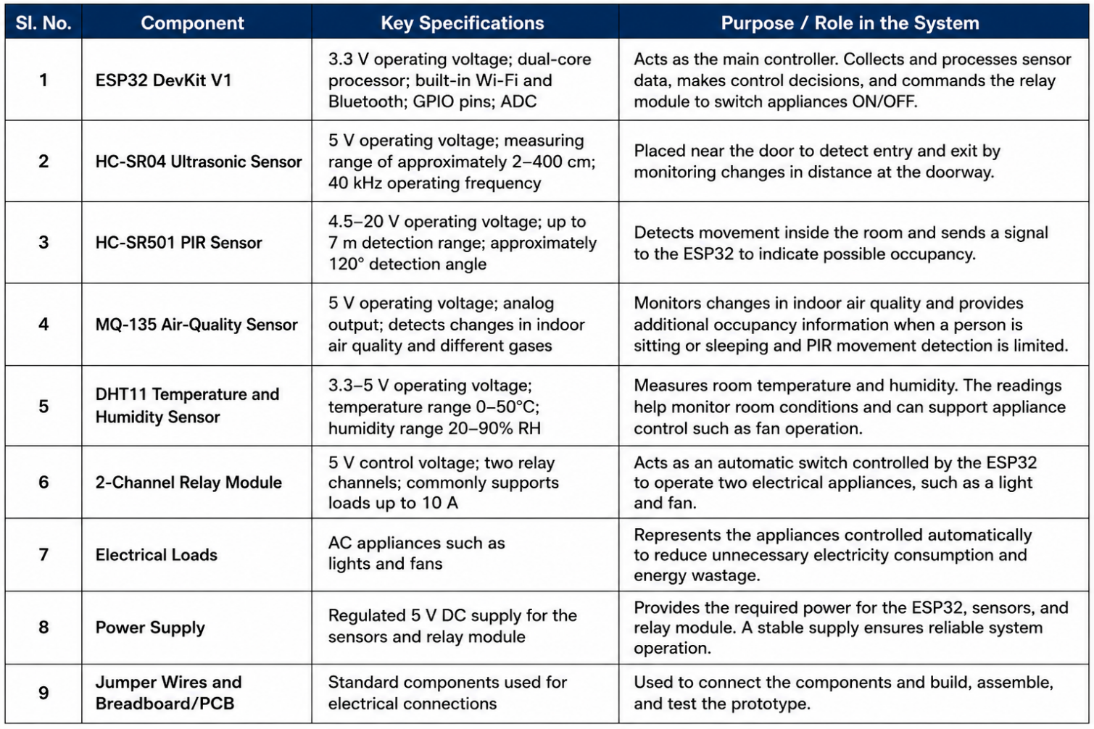

Multi-Sensor Based Occupancy Detection
The system uses a few sensors to check whether someone is inside the hostel room. The HC-SR04 sensor checks if someone enters or leaves the room. The PIR sensor checks if there is any movement inside the room. The MQ-135 sensor checks the air inside the room, and the DHT11 sensor checks the room temperature and humidity. All the information is sent to the ESP32, which acts like the brain of the system and decides whether someone is in the room or not.
Novelty: Of depending on one sensor the system uses different sensors to make the occupancy detection better.

Entry and Exit Detection Using HC-SR04
The HC-SR04 sensor is placed near the room door. It checks the distance in front of the doorway. Notices big changes when someone walks through. The ESP32 uses these changes to see when someone enters or leaves and updates the room status.
Novelty: The system uses a sensor at the door to see when people come in or go out instead of just checking movement inside the room.
Stationary Occupant Detection Using PIR and Environmental Sensing
A problem with the PIR sensor is that it might not see someone who is not moving like when they're sleeping, studying or sitting. To fix this the system also looks at the MQ-135 and DHT11 readings. Changes in the air quality, temperature and humidity help the system decide if the room is occupied when no movement is seen.
Novelty: The system tries to solve the problem of not seeing people who are not moving by adding checks.
Sensor-Fusion-Based Decision Making
The ESP32 is the decision maker. It takes data from the HC-SR04, PIR, MQ-135 and DHT11 sensors all the time. Of making a decision from one sensor the system looks at all the sensors together to control the appliances.
Novelty: Using data from sensors to decide if the room is occupied makes the system more trustworthy than using just one sensor.
Automated Occupancy and Environment-Based Energy Control
Once the system knows if the room is occupied and what the conditions are the ESP32 controls the appliances using the 2-channel relay module. Lights and other devices can be turned on when the room is in use and turned off when it is empty. The DHT11 temperature data can also help control the fan when the room gets too hot.
Novelty: The system combines checking if the room is occupied with checking the environment to save energy in hostel rooms.
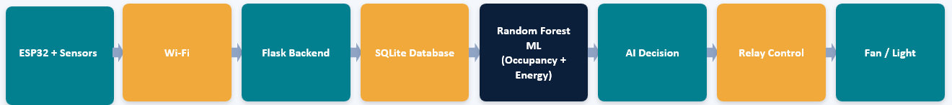
PROTOTYPE

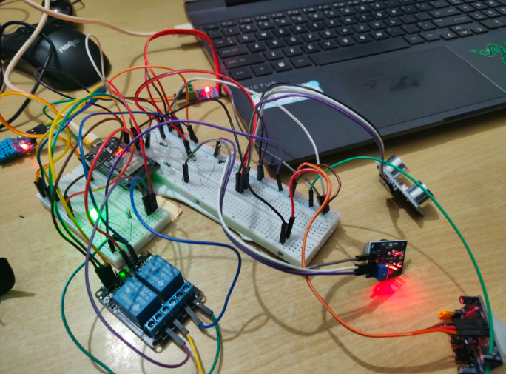
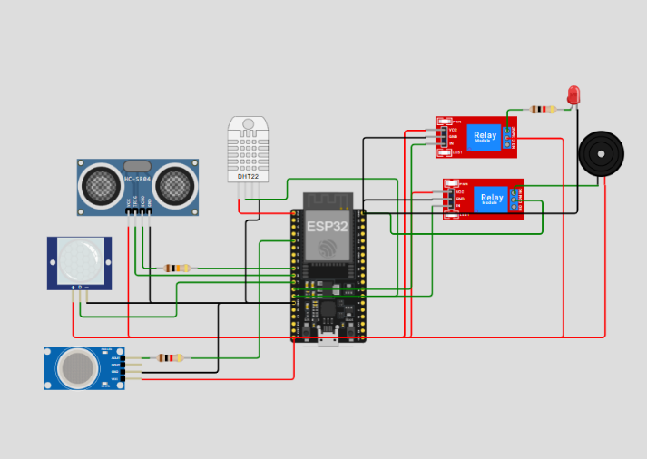
Fig: WOKWI MODEL Fig: ACTUAL MODEL

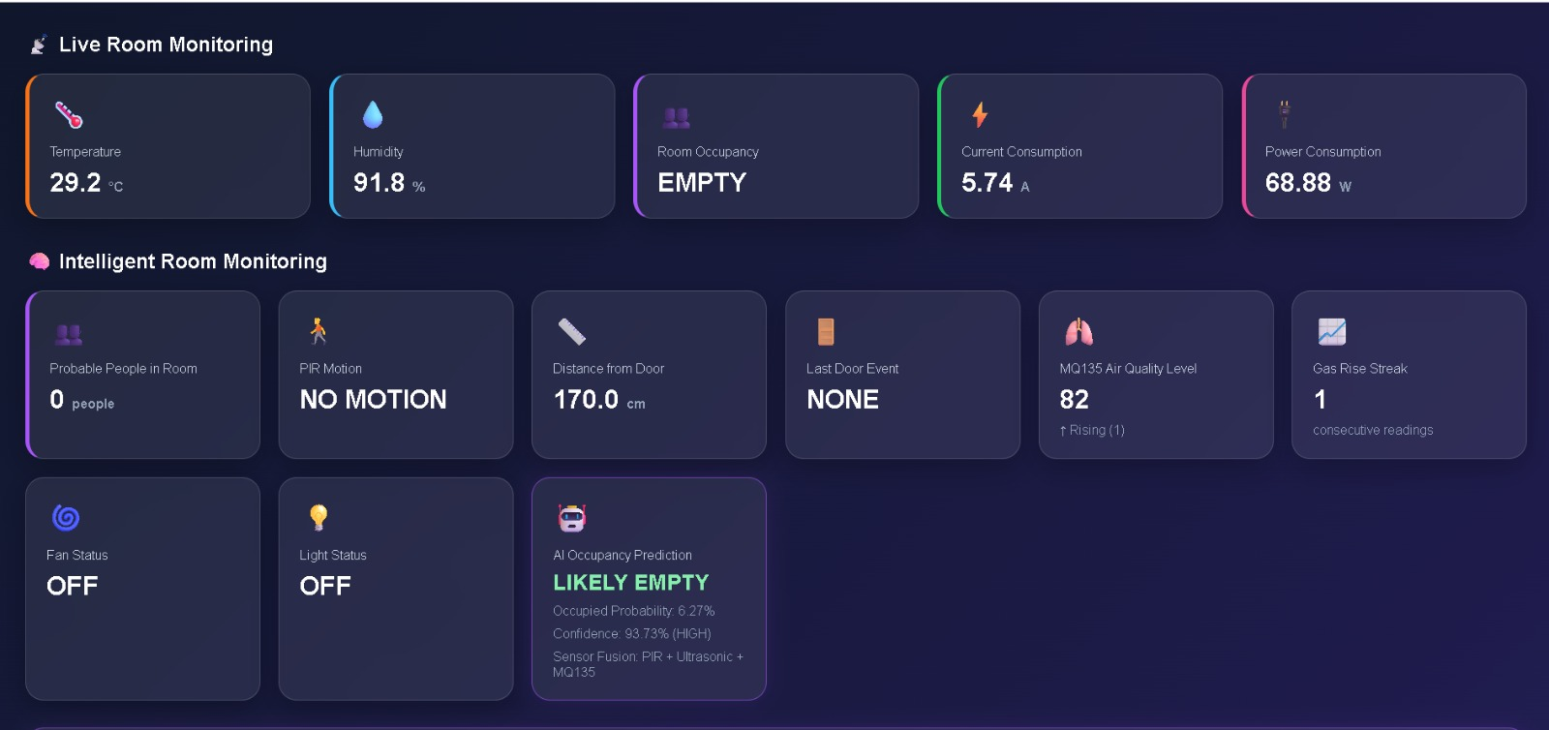
Fig: DASHBOARD SHOWING DIFFERENT FEATURES
Results
We tested the Smart Hostel Energy Management System using both a computer simulation and real hardware. The tests showed that the Smart Hostel Energy Management System can detect whether a room is being used and control appliances automatically.The HC‑SR04 sensor detects changes near the doorway to identify entry or exit. The PIR sensor detects movement inside the room. The DHT11 sensor measures temperature and humidity while the MQ‑135 sensor monitors changes in air quality.All sensor data is sent to the ESP32, which acts as the controller. Based on the sensor readings the ESP32 decides whether the room is occupied. The ESP32 then sends signals to the relay module to switch the connected appliances ON or OFF.The Smart Hostel Energy Management System works automatically. When a person enters the room or movement is detected the Smart Hostel Energy Management System considers the room occupied and keeps the appliances ON. When the room is empty for some time the Smart Hostel Energy Management System switches the appliances OFF.Overall, the simulation and hardware testing showed that the Smart Hostel Energy Management System works as expected. The Smart Hostel Energy Management System can help reduce electricity usage by preventing appliances from being left ON when the room is not, in use.
Applications
1)Hostel Rooms – Automatically controls lights and fans based on room occupancy, reducing unnecessary energy consumption.
2)Homes – Manages household appliances such as lights and fans based on occupancy and room conditions.
3)Classrooms – Automatically switches off appliances when classrooms are unoccupied.
4)Offices – Reduces electricity wastage by controlling appliances in unused rooms.
5)Hotels – Controls room appliances when guests are away, improving energy efficiency.

Future Prospects
1) The system can be connected to IoT platforms, allowing users to monitor room conditions and control appliances remotely through a smartphone or web interface.
2) More accurate and advanced sensors can be integrated to improve occupancy detection and reduce false decisions, especially when occupants remain still for long periods.
3) Energy meters can be added to measure the electricity consumed by individual appliances, helping identify energy wastage and optimize power usage.
4) Machine learning can be further developed to analyse room-usage patterns, predict occupancy, and automatically optimize appliance operation based on learned behaviour.
5) The system can be expanded to control more appliances and multiple rooms while providing notifications about appliance status, unusual conditions, or excessive energy consumption.

Conclusion
The Smart Hostel Energy Management System was developed to control appliances automatically based on room usage. The system uses sensors to collect information about movement, entry and exit temperature, humidity and air quality.The ESP32 receives the sensor information. Checks the condition of the room. Based on this information it sends commands to the relay module to turn the connected appliances ON or OFF.The simulation and hardware tests showed that the system can work as expected. When the room is, in use the system keeps the appliances ON. When the room is not being used it can turn the appliances OFF. This helps reduce electricity use and prevents energy waste.Overall, the project shows a way to manage electrical appliances automatically. With improvements the system can become more accurate and useful for hostels, homes, classrooms, offices, hotels and other buildings.

References:
- M. Simeon, E. Amuta, S. T. Wara, A. Adoghe, and H. Orovwode, “Efficient Energy Management System Using PIR Sensor,” 2018 IEEE PES/IAS PowerAfrica, 2018.
- S. S. S. Velan and V. Kirubakaran, “Implementation of Energy Conservation and Management Activities and its Economics in GRI Boy’s Hostel—A Case Study,” 2016 Biennial International Conference on Power and Energy Systems: Towards Sustainable Energy (PESTS), 2016.
- T. K. Singhal, Saurabh, I. Vashishtha, and P. Chugh, “IoT Enabled Smart Hostel: A Futuristic Perspective,” International Journal for Research in Applied Science & Engineering Technology, vol. 5, no. IX, 2017.
- M. O. Agyeman, Z. Al-Waisi, and I. Hoxha, “Design and Implementation of an IoT-Based Energy Monitoring System for Managing Smart Homes,” 2019 Fourth International Conference on Fog and Mobile Edge Computing (FMEC), 2019.
- N. H. Motlagh, M. Mohammadrezaei, J. Hunt, and B. Zakeri, “Internet of Things (IoT) and the Energy Sector,” Energies, vol. 13, no. 2, p. 494, 2020. doi: 10.3390/en13020494.
- M. U. Saleem, M. R. Usman, and M. Shakir, “Design, Implementation, and Deployment of an IoT Based Smart Energy Management System,” IEEE Access, vol. 7, pp. 160131–160142, 2019.
- A. R. Al-Ali, I. A. Zualkernan, M. Rashid, R. Gupta, and M. AliKarar, “A Smart Home Energy Management System Using IoT and Big Data Analytics Approach,” IEEE Access, vol. 7, pp. 14406–14416, 2017.
- K. Chooruang and K. Meekul, “Design of an IoT Energy Monitoring System,” 2018 16th International Conference on ICT and Knowledge Engineering, Bangkok, Thailand, 2018.
- S. Bhardwaj, Venkadeshwaran K., M. F. Ansari, B. P. Dash, P. Sharma, and D. P. Singh, “Hybrid Technology Based Smart Hostel Management System Using Artificial Intelligence and Internet of Things,” 2020.
- B. P. Pathri, J. M. C. K. Reddy, V. S. H. Borra, M. R. Kantipudi, K. V. Ganduri, and M. R. Jupalle, “Smart Hostel Management Through the IoT: Reducing Energy Consumption, Securing Access, and Preventing Theft,” Proceedings of the Third International Conference on Automation, Computing and Renewable Systems (ICACRS-2024), IEEE, pp. 483–488, 2024.
- W. Tushar, C. Yuen, B. Chai, S. Huang, K. L. Wood, S. G. Kerk, and Z. Yang, “Smart Grid Testbed for Demand Focused Energy Management in End User Environments,” IEEE Wireless Communications, 2016. doi: 10.1109/MWC.2016.1400377.
- M. Patil, V. D. Chaudhari, H. V. Dhande, and H. T. Ingale, “Hostel Rooms Power Management and Monitoring Using Internet of Things,” Computing, Communication and Signal Processing, Advances in Intelligent Systems and Computing, vol. 810, pp. 195–204, Springer, 2019. doi: 10.1007/978-981-13-1513-8_19.
- S. Singh and M. Nezami, “Edge-Assisted Smart Campus Energy Management using Federated Learning and Context-Aware Control,” International Journal of Science, Strategic Management and Technology, vol. 2, no. 5, 2026.
- H. D. Abubakar, I. G. Abdulhamid, and B. M. Ahmad, “Effective Energy Conservation System for Hostels,” International Journal of Latest Technology in Engineering, Management & Applied Science (IJLTEMAS), vol. IX, no. VII, 2020.
- G. K. Yii, R. Abdulla, and R. B. Yusop, “Hostel Power Switching Card System,” Journal of Applied Technology and Innovation, vol. 6, no. 2, p. 29, 2022.
- S. S. Usoro, J. P. Iloh, C. B. Mbachu, and C. G. Dilibe, “Development of an Internet of Things Based Campus Energy Management System,” International Journal of Emerging IoT Technologies in Smart Electronics and Communication, vol. 1, no. 1, pp. 37–50, 2025.
- A. K. B. and K. N. Nikam, “A Case Study of the Energy Performance of A–J Hostel Block in IIM, Bangalore,” Transactions on Energy Systems and Engineering Applications, 2025.
- V. Kalidhasan, B. Lawrance, A. Punitha, and M. A. A. M. F. Mohamed Ashik Ahamed, “IoT-Based Smart Hostel Food Management with Integrated Carbon Footprint Trackers,” Proceedings of the 10th International Conference on Communication and Electronics Systems (ICCES-2025), 2025.
- A. O. Adepoju, K. J. Ekundayo, O. A. Aladejebi, A. N. Abasilim, O. A. Jesuleye, and S. A. Oyetunji, “Energy Conservation Behaviour and Sufficiency among University Hostel Students: An Exploratory Study,” Global Journal of Environmental Science & Sustainability, 2025. doi: 10.69798/92924777.
- J. Ravi Kumar, D. A. Srija, B. Charishma, D. Neelima, K. Prasanna, and B. Harshitha, “Hostel Management System with ML-based Room Vacancy Prediction and Real-Time Facility Tracking for Freshers,” 2026 International Conference on Data Science, Agents, and Artificial Intelligence (ICDSAAI 2026), Chennai, India, 2026.
- B. Saathvik, S. Sivabalan, and R. Ramalingam, “Room Dot View: Hostel Visionary Approach in Sustainable Design and DevOps 2024,” 2024.

